**LAB 11**

Questions:

1. Write a program in C++ which takes input from user and contains a

procedure in assembly named ThreeProd that displays the product of

three numeric parameters passed in a function argument.

2. Write a program in C++/C which takes input from user and contains a

procedure in assembly named GCD(Greatest common divisor) which

calculates their GCD.

Q1

Code :

C++  
#include <iostream>

using namespace std;

extern "C" int ThreeProd(int val1, int val2, int val3);

int main()

{

int val1, val2, val3 , result ;

cout << "Enter the value 1: ";

cin >> val1;

cout << "Enter the value 2: ";

cin >> val2;

cout << "Enter the value 3: ";

cin >> val3;

result = ThreeProd(val1 , val2 , val3);

cout << "Result = " << result;

}

MASM

.686 ;Target processor Use instructions for Pentium class machines

.MODEL FLAT, C ;Use the flat memory model Use C calling conventions

.STACK 2048

.code

PUBLIC ThreeProd

ThreeProd PROC

mov eax, [esp+4]

mov ebx, [esp+8]

mov ecx, [esp+12]

mul ebx ; eax = eax * ebx

mul ecx

ret

ThreeProd ENDP

END

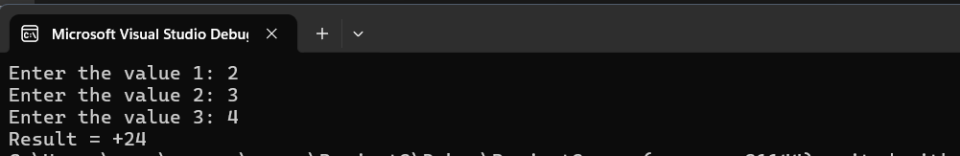

Q2

Code:

C++

#include <iostream>

using namespace std;

extern "C" int GCD(int val1, int val2);

int main()

{

int val1, val2 , result ;

cout << "Enter the value 1: ";

cin >> val1;

cout << "Enter the value 2: ";

cin >> val2;

result = GCD(val1 , val2);

cout << "GCD = " << result;

}

MASM

.686 ;Target processor Use instructions for Pentium class machines

.MODEL FLAT, C ;Use the flat memory model Use C calling conventions

.STACK 2048

.code

PUBLIC GCD

GCD PROC

mov eax, [esp+4]

mov ebx, [esp+8]

L1:

xor edx, edx

div ebx

mov eax, ebx

mov ebx, edx

cmp ebx, 0

jne L1

ret

GCD ENDP

END

